ENTERING A CREDIT MEMO

To enter a miscellaneous credit memo that will basically correct your sales, go to AW1

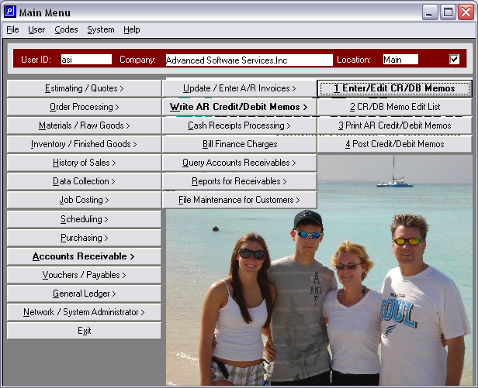
Click the add button on the header of the screen and enter
The customer number and memo date, then click save.
When you click save a popup will come up with a list
Of the open invoices. Choose the invoice you want to
Credit and click ok.

You will then need to click on that line item using the buttons at
Bottom of screen and click update. Change the amount to the
Credit amount making sure that you put a negative before the
Amount and then tab over to the sales account number and
Change it if you need to. Click save.

You will then need to go back to the menu and print the
Credit memo and then post.

